FOR IMMEDIATE RELEASE

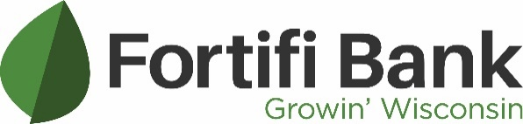
Contact:
Daniel Aronson
Marketing Manager, Fortifi Bank
daronson@fortifibank.com
920.354.4141

Fortifi Bank’s Dave Mills Inducted into WBD Hall of Fame

October 10, 2024 – Waunakee, Wis. – Fortifi Bank proudly announces that Dave Mills, Market President and Senior Lender, was inducted into the WBD Hall of Fame at an appreciation event held at Lawsonia in Green Lake. This prestigious and exclusive recognition is given to lenders who have closed over 20 Small Businesses Administration (SBA) 504 loan projects with WBD and have significantly contributed to business development in their communities.
Dave Mills, a long-standing partner and advocate for the 504 loan program, has partnered with WBD on an impressive 29 projects, totaling over $40 million in funding. His contributions have led to the creation of thousands of jobs in Wisconsin, and he is highly regarded for his dedication to supporting the state's economic growth.
The SBA 504 loan program provides small businesses with long-term, fixed-rate financing for major fixed assets like real estate, equipment, and improvements. By partnering with lenders like Fortifi Bank and Certified Development Companies (CDCs) such as WBD, the program promotes economic development and job creation in local communities.
During the event, Dave Mills was honored with a medal and a gift from WBD's president and CEO, Dan Schneider, in recognition of his exceptional accomplishments and lasting impact on the community. Mills joined an esteemed group of WBD Elite Lenders and WBD Hall of Famers who have reached this milestone.
“He’s a true believer in the 504 loan program and WBD, and very much appreciated by all of us here,” said Dan Schneider of WBD. “Dave’s enthusiasm for the program has not only helped create opportunities for countless small businesses but also strengthened the fabric of communities throughout Wisconsin. His dedication and commitment to our mission make him a valued partner and friend to WBD.”
“Dave’s achievements embody our mission of ‘Growin’ Wisconsin,’” said Greg Lundberg, president and CEO of Fortifi Bank. “His commitment to supporting local businesses and fostering economic growth truly reflects the values that Fortifi Bank stands for. We are incredibly proud of his impact and the continued success he brings to our clients and communities.”
For more information on the SBA 504 loan program and WBA, visit http://www.wbd.org.
About Fortifi Bank:
First Berlin Bancorp, Inc is the Bank Holding Company of Fortifi Bank. Fortifi Bank has been Growin’ Wisconsin for more than 145 years – one person, one business, one relationship at a time. Financial centers can be found in Berlin, Green Lake, Green Bay, Montello, Ripon, Omro, Oshkosh, Waunakee, and Winneconne. Their full-service financial centers have been offering both personal and business clients with a portfolio of products and services that are designed with the client in mind. Local decision-making, community involvement, community ownership, and a Board of Directors comprised of local citizens have been the driving successes of Fortifi Bank since inception. For more information, visit www.fortifibank.com or call 855-876-1500.

###

